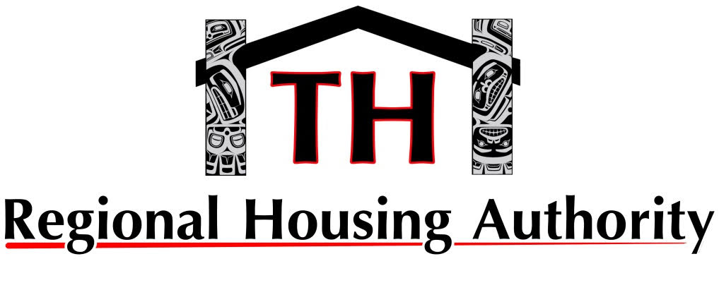
Media contact:
Kenneth Southerland
Director of Administration
Tlingit Haida Regional Housing Authority
ksoutherland@thrha.org | (907) 780-3126

Tlingit Haida Regional Housing Authority Appoints New Chief Operating Officer
FOR IMMEDIATE RELEASE
July 11, 2025
Juneau, Alaska – The Tlingit Haida Regional Housing Authority (THRHA) is pleased to announce the appointment of Esther Aaltséen Reese as its new Chief Operating Officer, effective mid-June. Aaltséen will be based in Juneau and will play a pivotal leadership role in advancing THRHA’s mission of connecting Southeast Alaskans with sustainable housing opportunities and innovative financial solutions.
Aaltséen brings more than 13 years of leadership experience from the Wrangell Cooperative Association, where she most recently served as Tribal Administrator. Her track record includes building strong partnerships and delivering impactful community solutions. Among her many accomplishments, Aaltséen led the Wrangell Cooperative Association in securing a federal disaster declaration. Her persistence and leadership brought critical assistance to the Wrangell community following a devastating landslide.
“Housing is the No. 1 need across Southeast Alaska,” Aaltséen shared in a recent interview with the Wrangell Sentinel on May 8.
Aaltséen will succeed Joyce Niven, who is retiring after nearly 25 years of dedicated service to THRHA. Joyce’s deep institutional knowledge and steady leadership will be deeply missed. THRHA extends heartfelt gratitude and best wishes to Joyce in her retirement.
###
About the Tlingit Haida Regional Housing Authority (THRHA)
THRHA, founded in 1973, has served Southeast Alaskans for over 50 years with a strong commitment to provide housing programs and financial solutions. To learn more, visit https://www.regionalhousingauthority.org.

